13). Create a Virtual Hard Disk and allocate the storage using VM ware workstation.

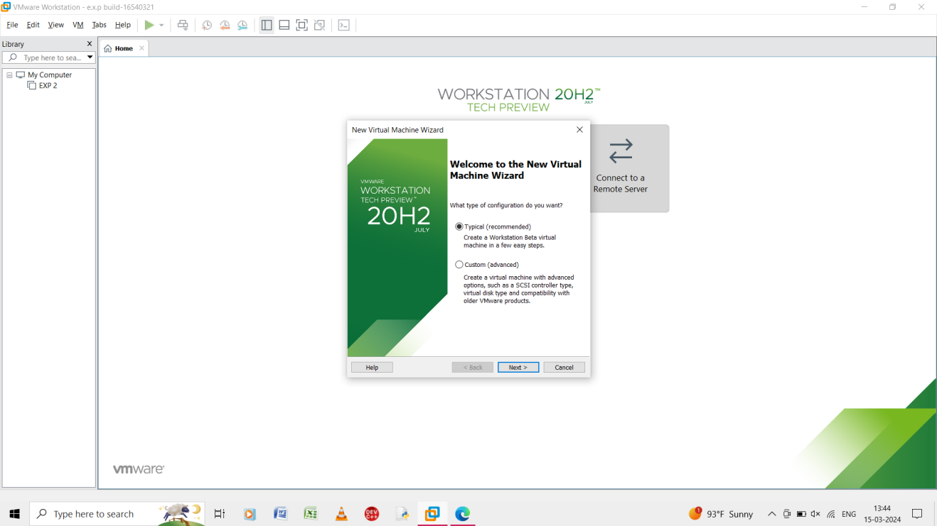

Step 1: to go file and create a new virtual machine and select typical.

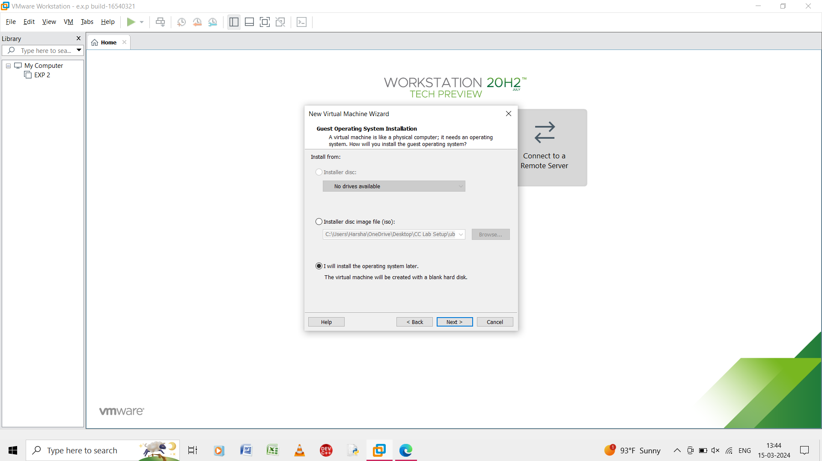

Step 2: in the guest operating system select the I will install the operating system later.

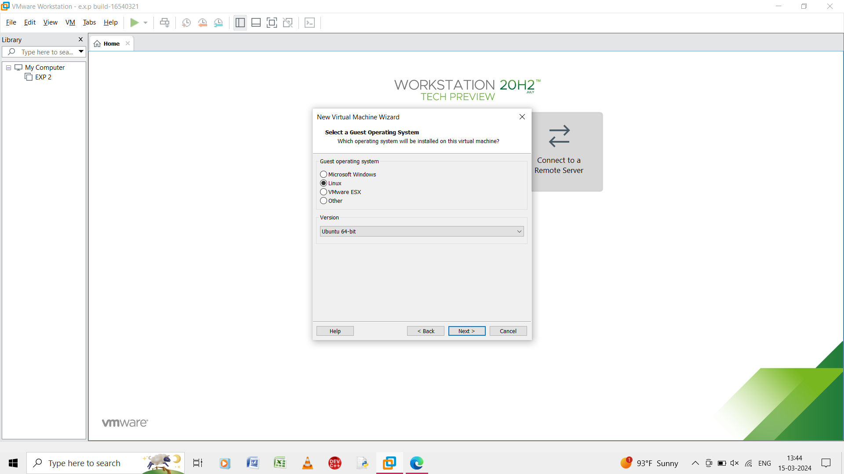

Step 3: select the guest operating system as linux

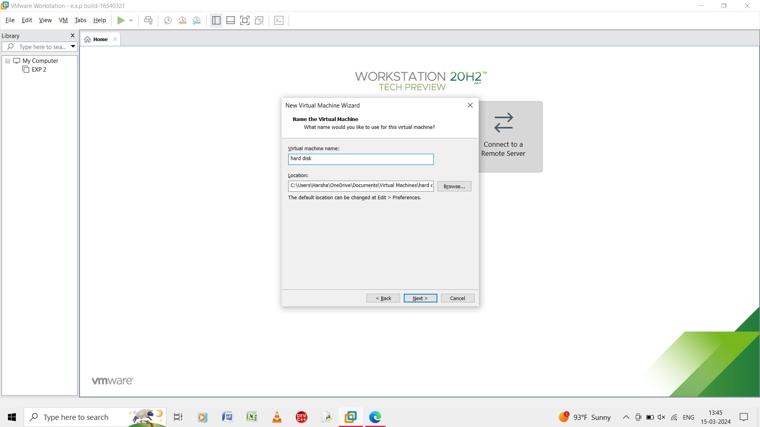

Step 4: give the name of the virtual machine as Hard disk.

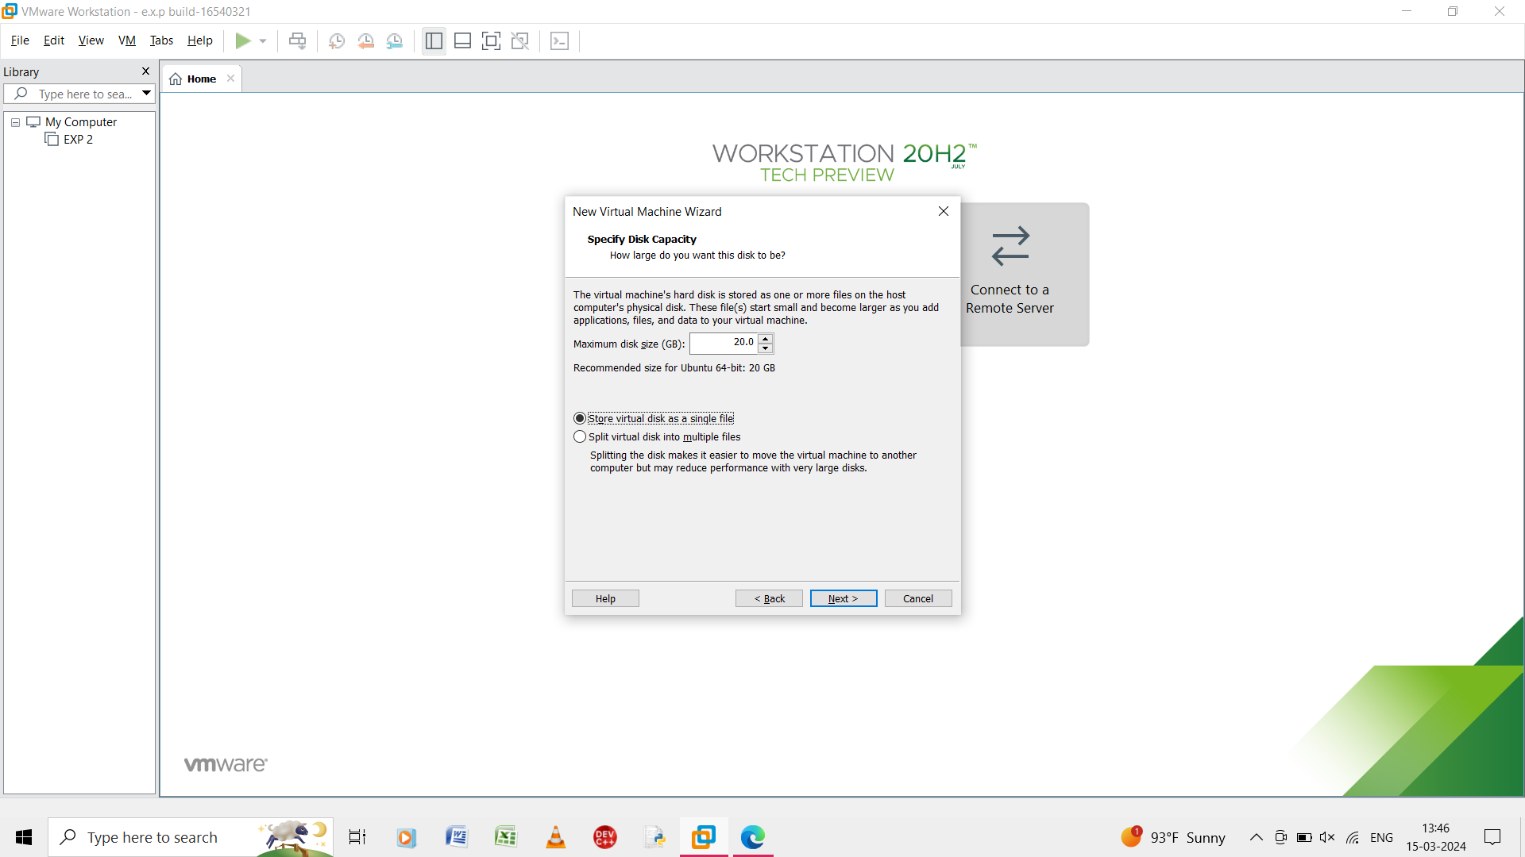

Step 5: in the specify disk capacity give maximum disk size and store the virtual disk in a single file.

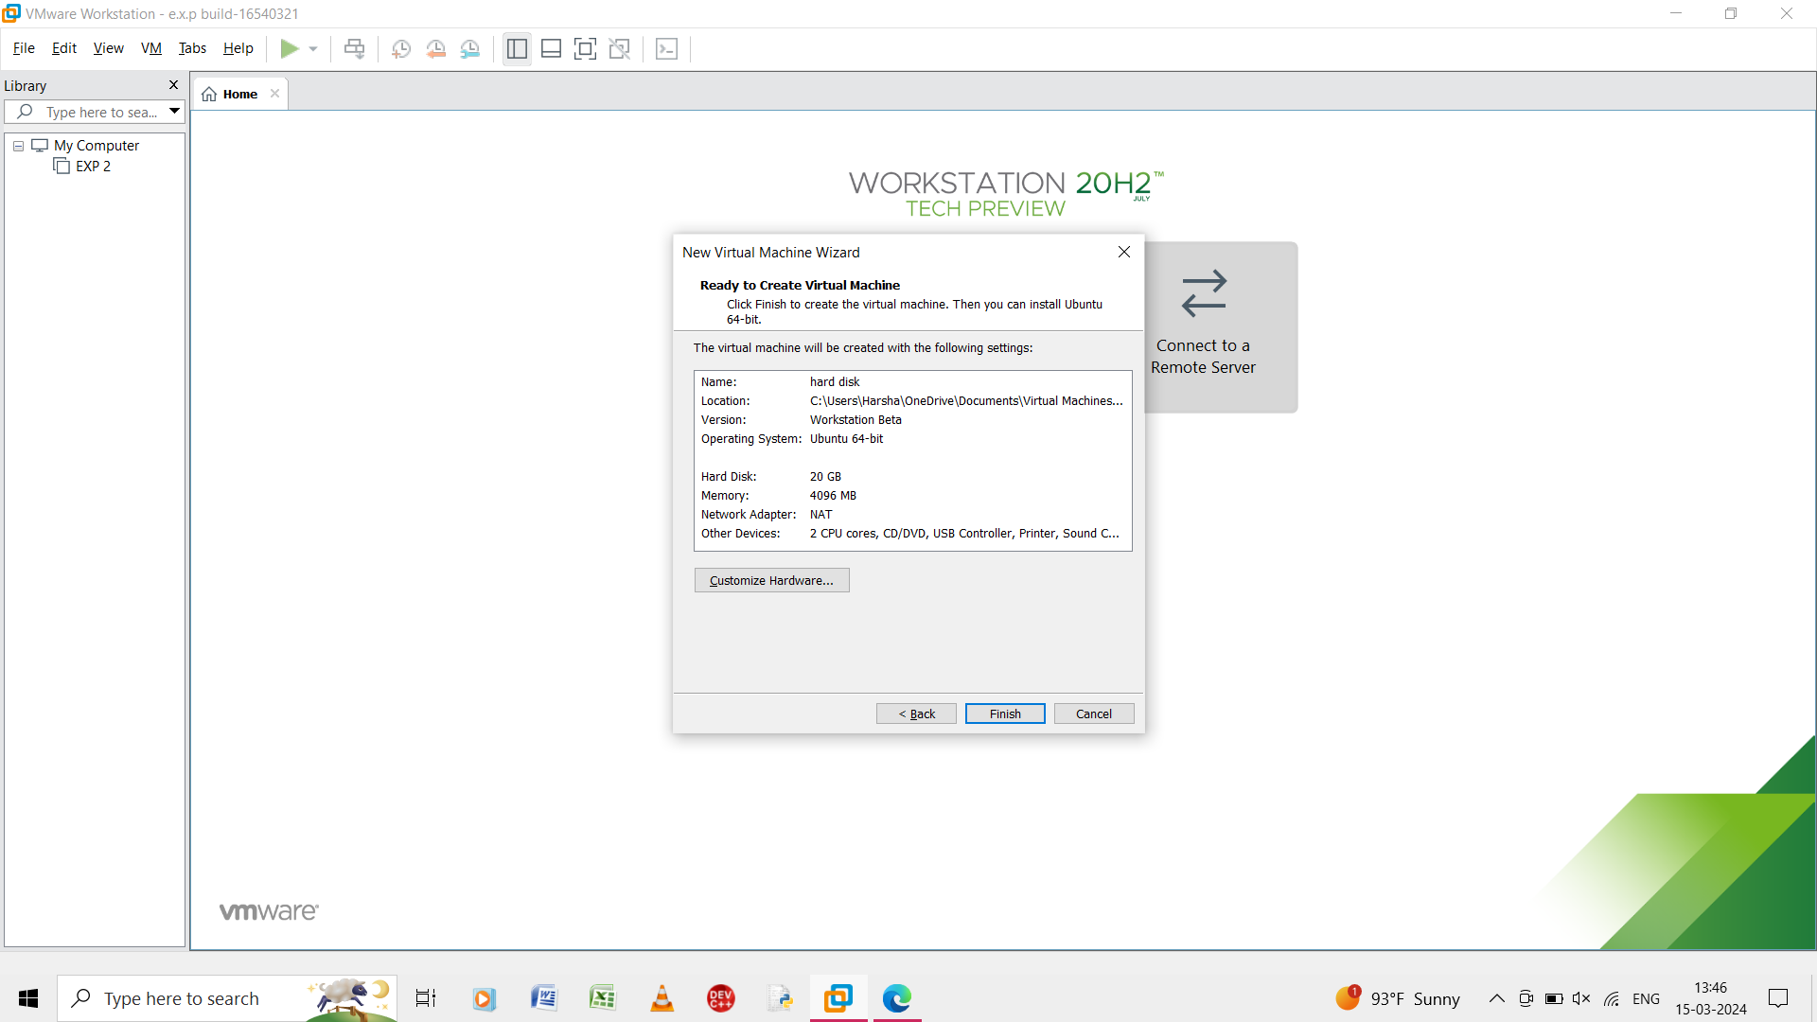

Step 6: in this step it is ready to create the vitual machine and it shows the summary of the virtual machine of the input.

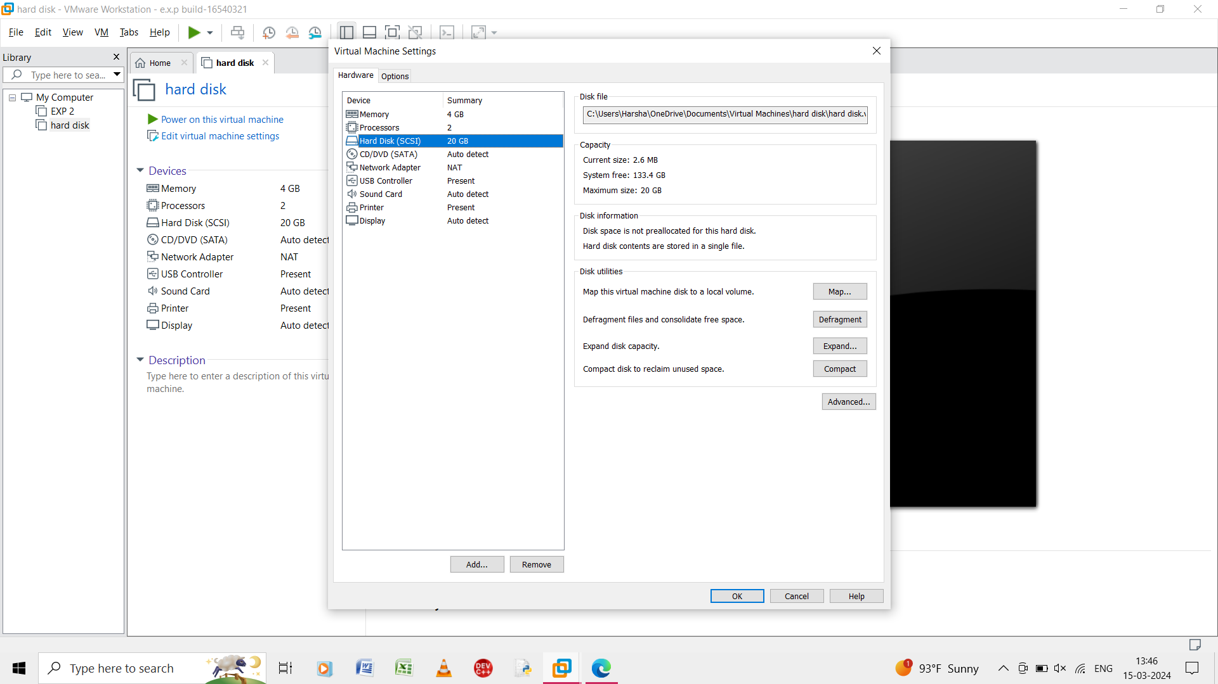

Step 7: click the hard disk and select the add option .

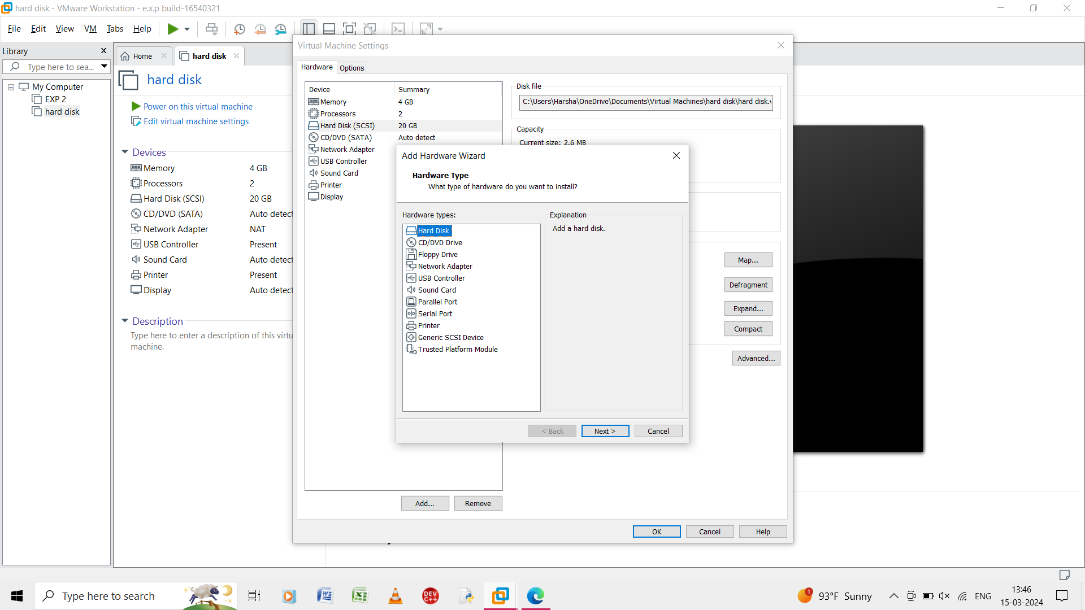

Step 8: select the hard disk type and click next.

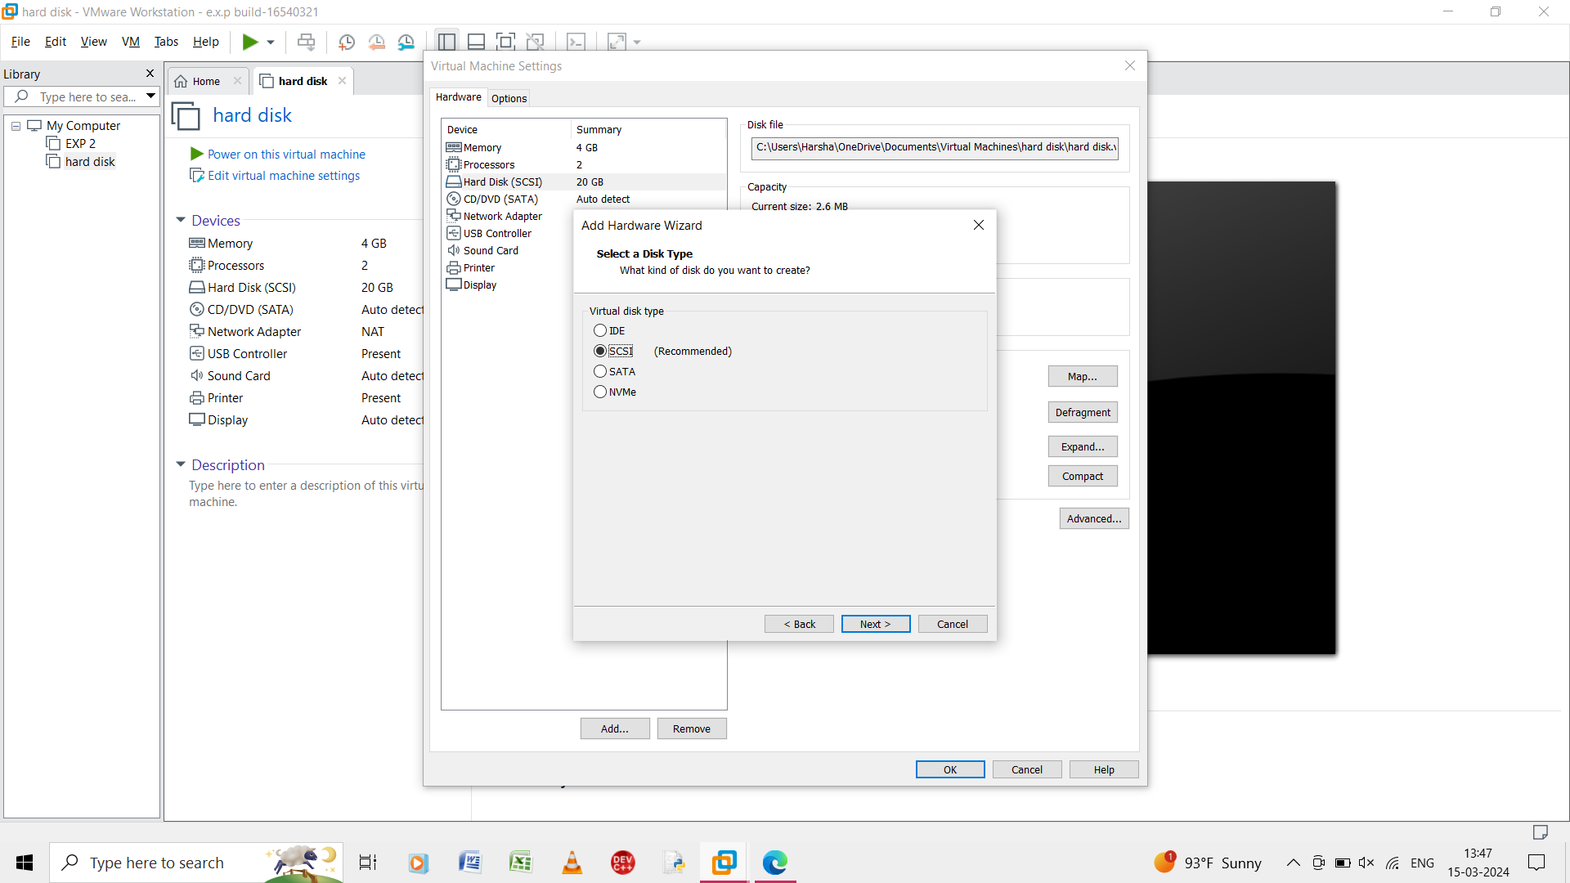

Step 9: select the virtual disk type as scsi and click next.

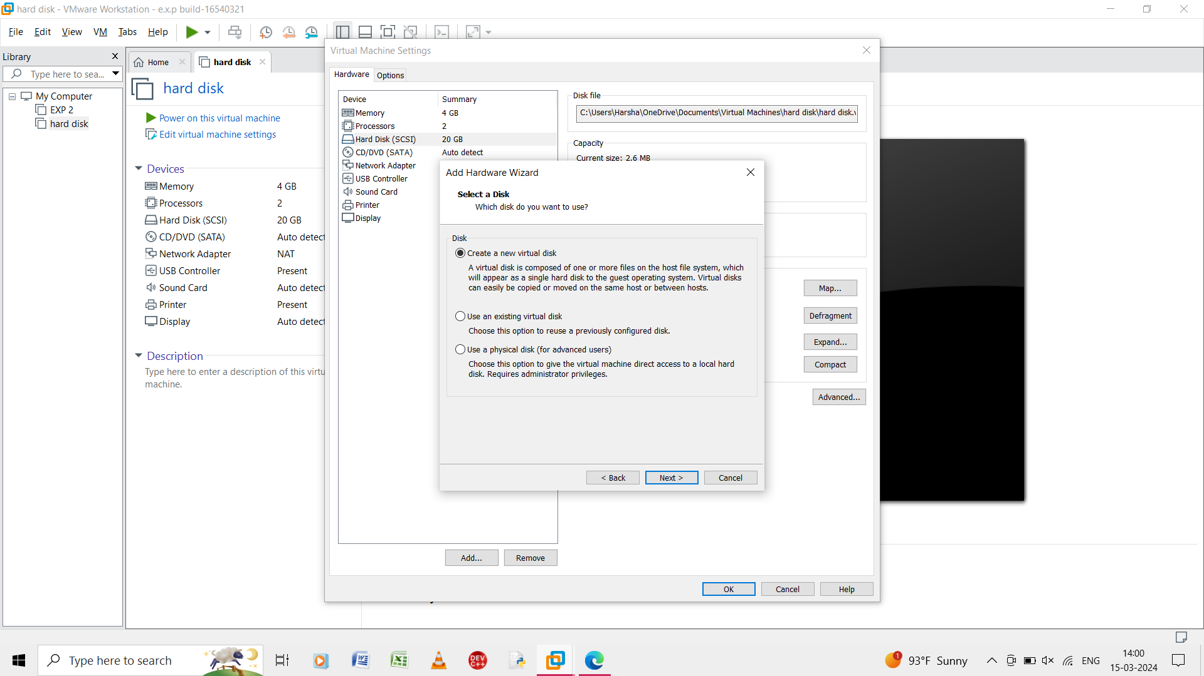

Step 10:click new virtual disk and click next.

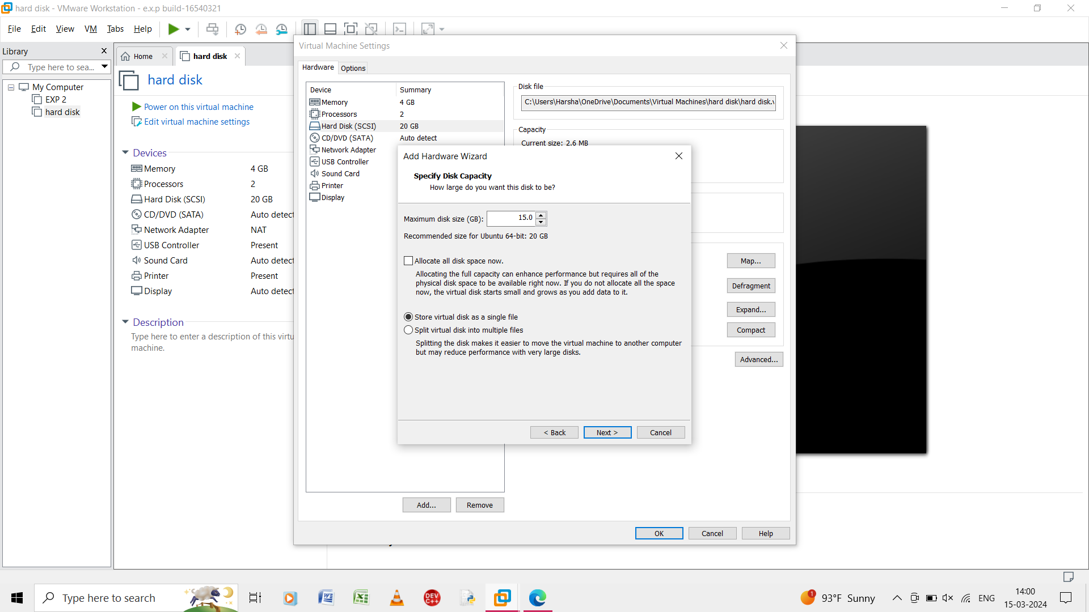

Step 11:add the maximum disk size and select the store virtual disk as a single file.

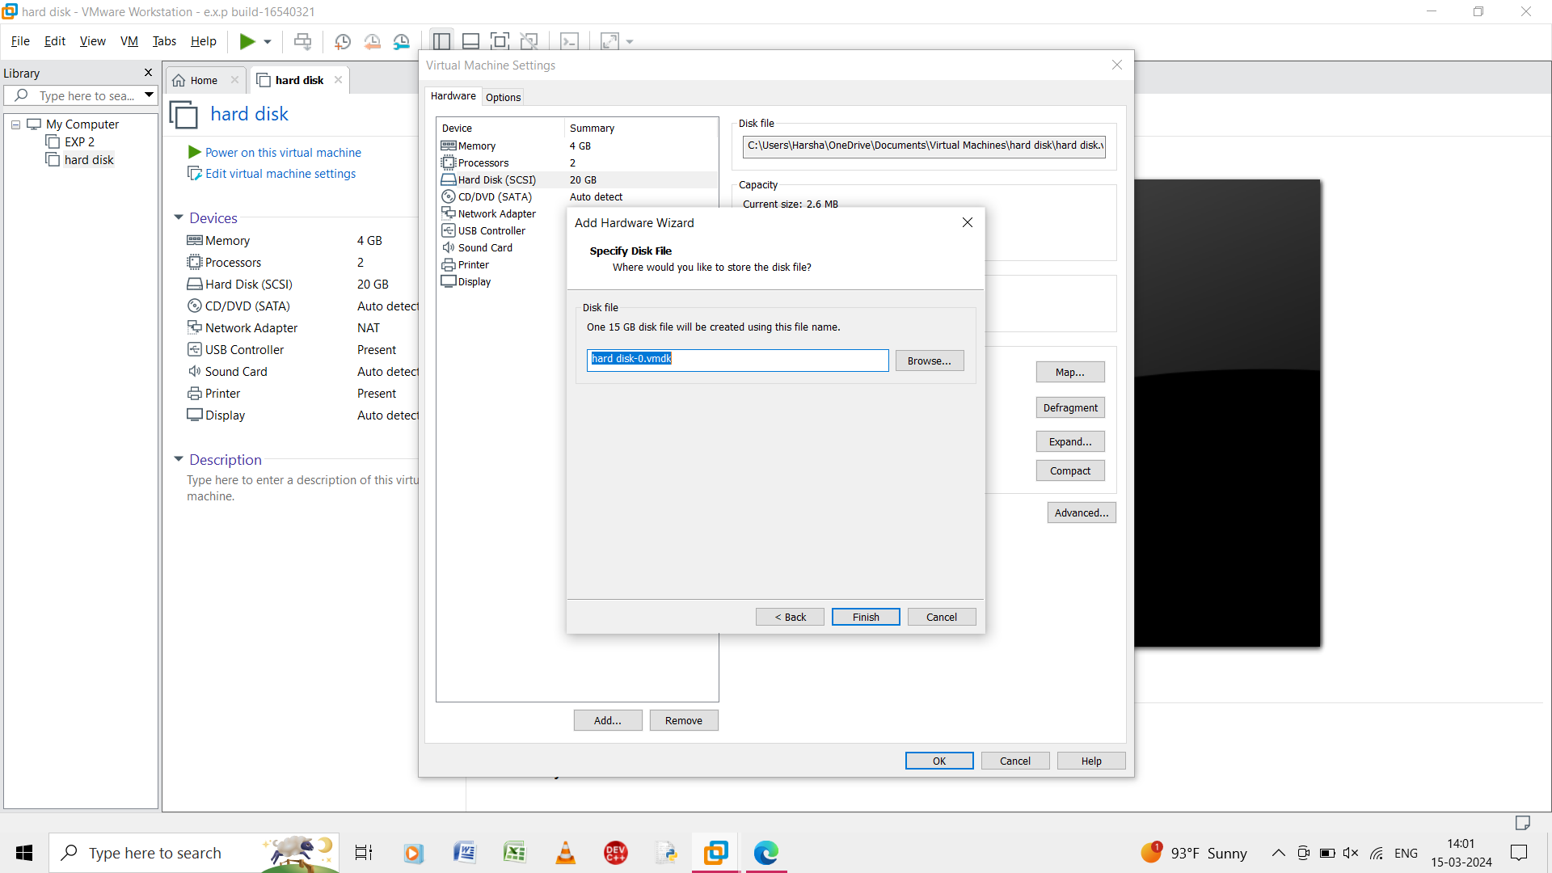

Step 12:select the disk file and click finish.

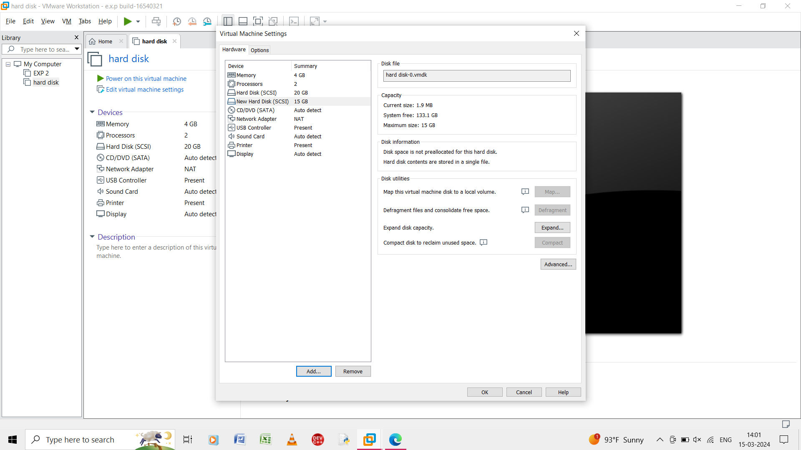

Step 13:the added hard disk is shown in the virtual machine settings.

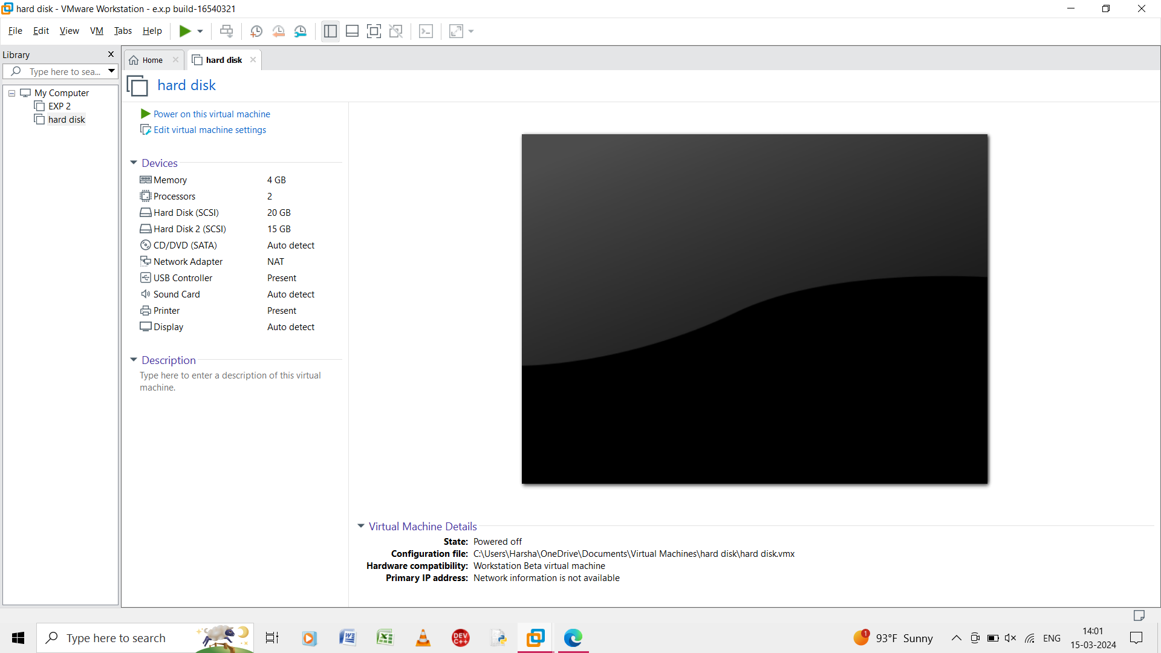

Step 14: the virtual machine that added the extra hard disk is shown.